**BUILDING FACE DETECTION APP ON AWS**

**NAME: N.SAI PRIYA**

**AWS LOGIN:**

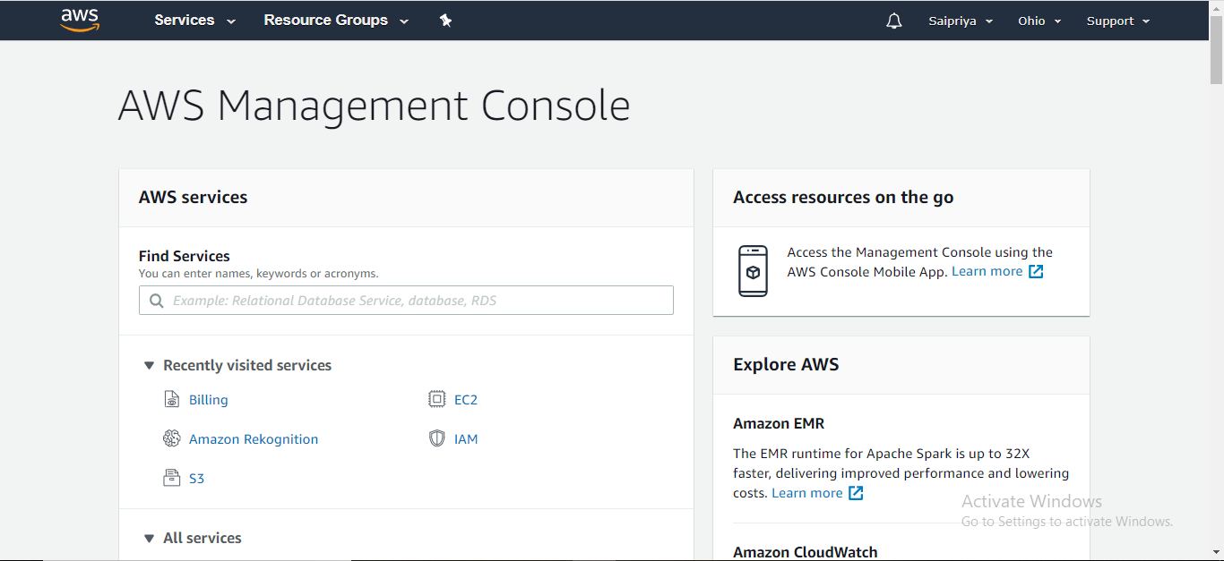

**EC2-DASHBOARD:**

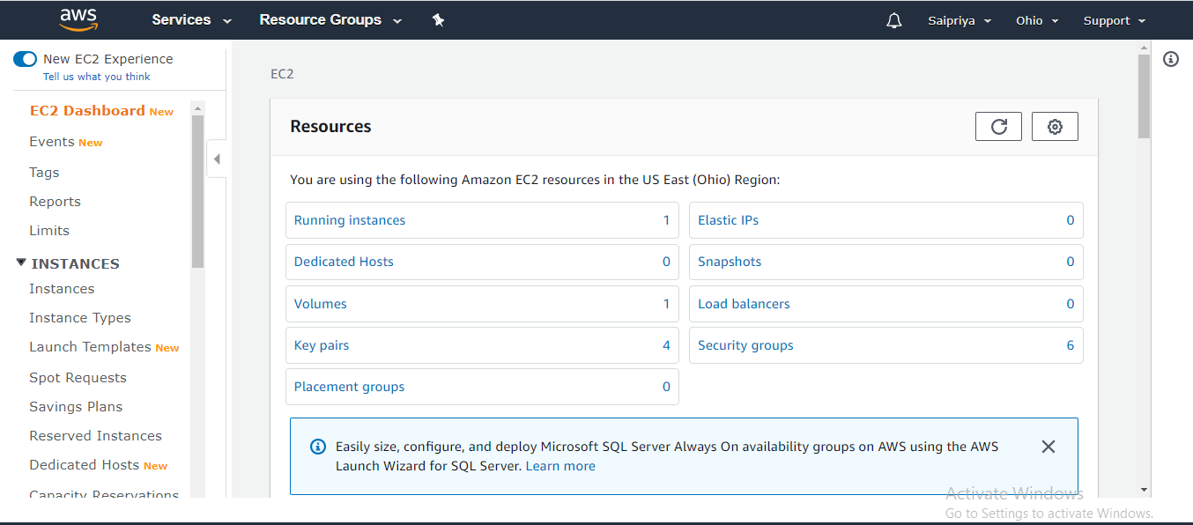

**S3 DASHBOARD:**

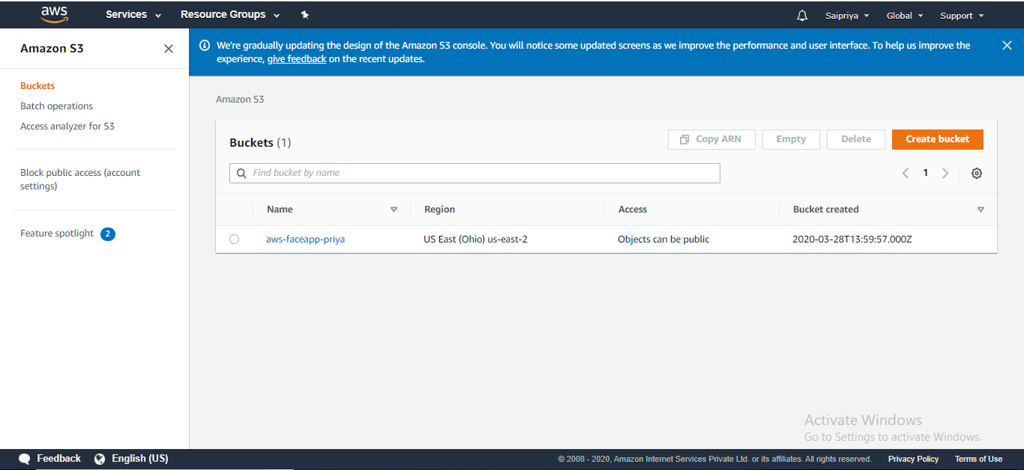

**REKOGNITION DASHBOARD:**

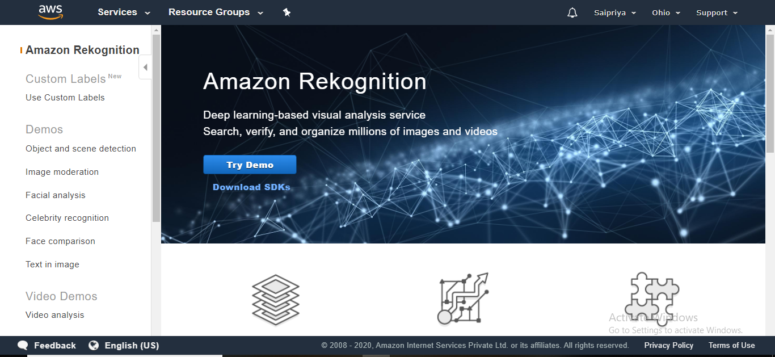

**EC2:**

1. **CHOOSING AMI:**

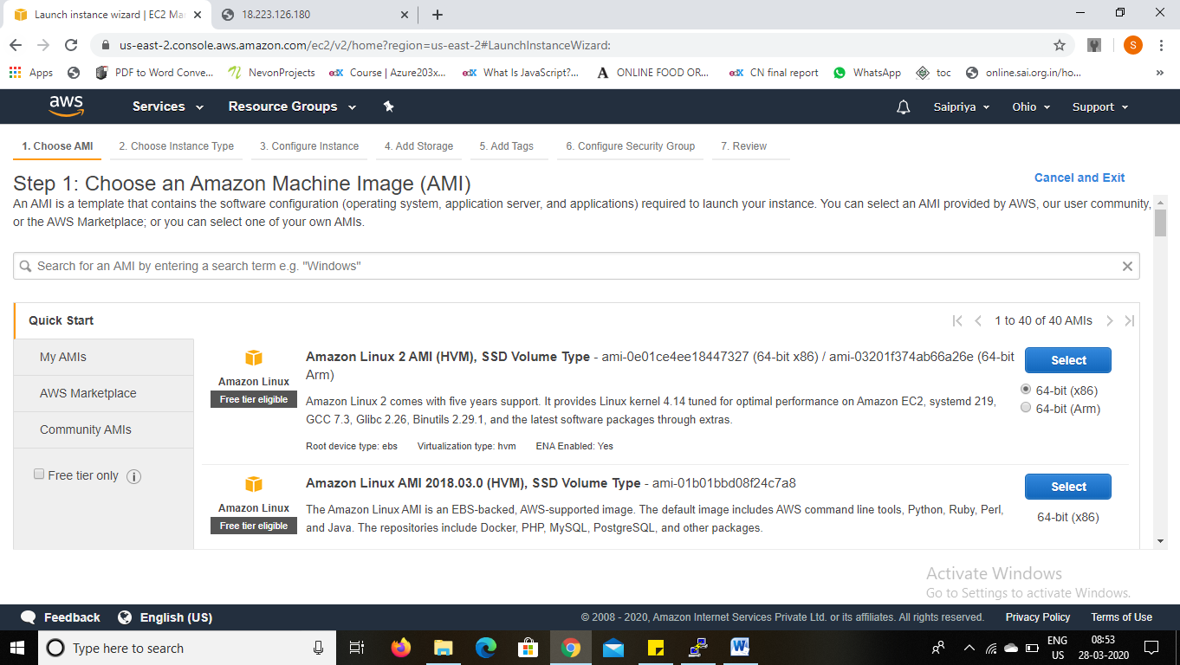

1. **CHOOSE INSTANCE TYPE:**

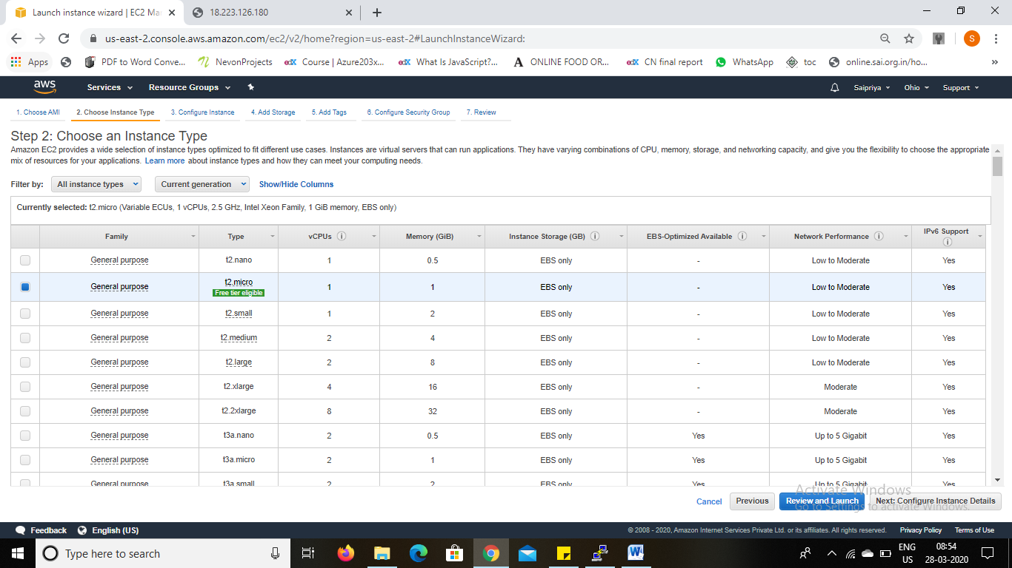

**CONFIGURE INSTANCE DETAILS:**

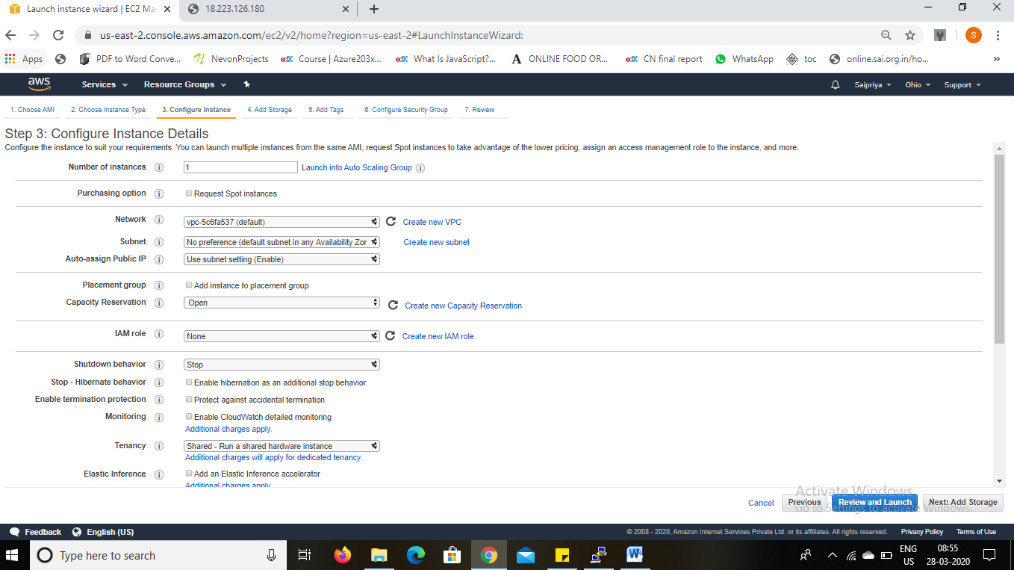

1. **ADD STORAGE:**

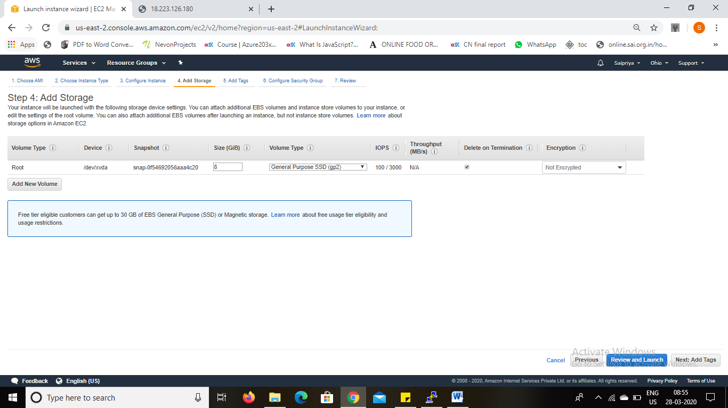

**ADD TAGS:**

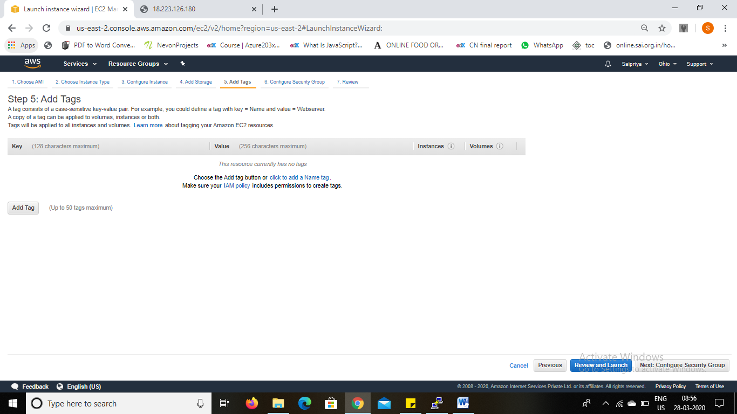

1. **CONFIGURE SECURITY GROUP:**

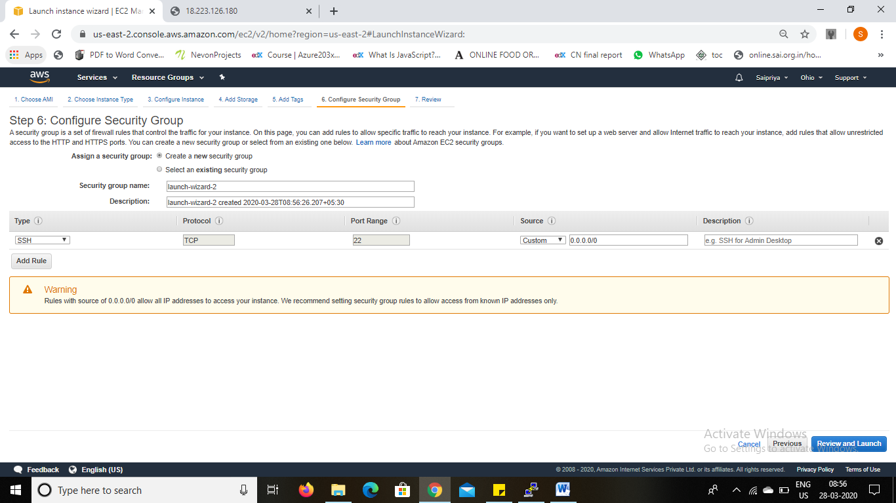

**REVIEW LAUNCH INSTANCE:**

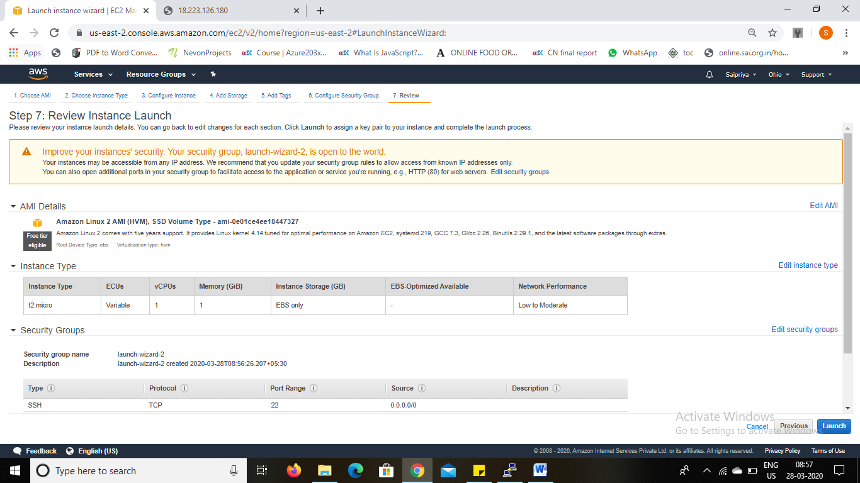

1. **KEY PAIR DOWNLOAD:**

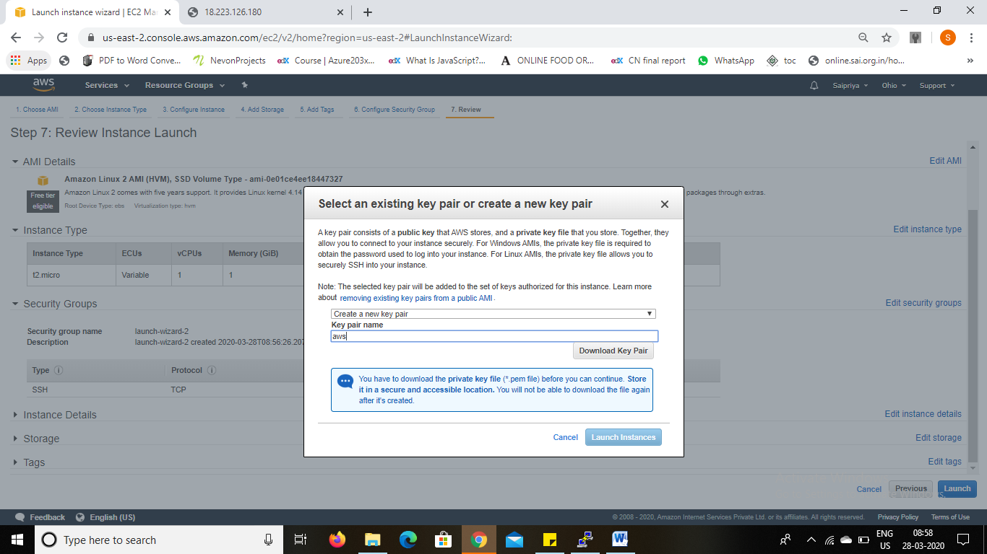

**INSTANCE LAUNCH STATUS:**

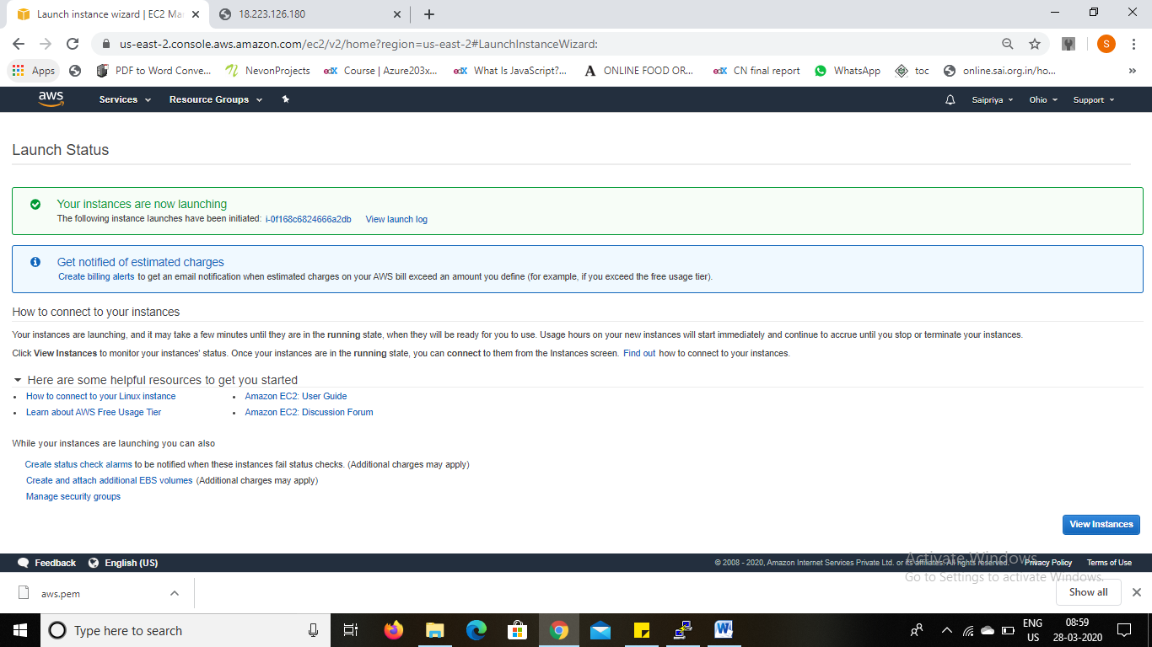

**LAUNCHED INSTANCE:**

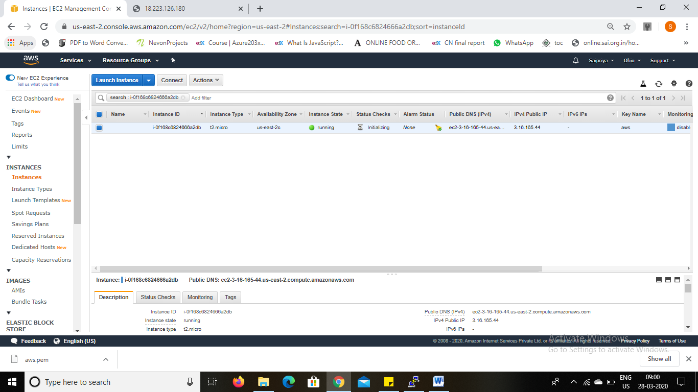

1. **PUTTYGEN CONVERSION FROM PEM TO PPK:**

**Loading .pem file(private key):**

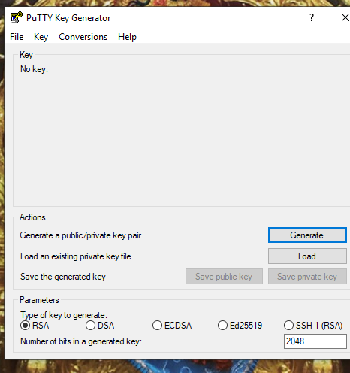

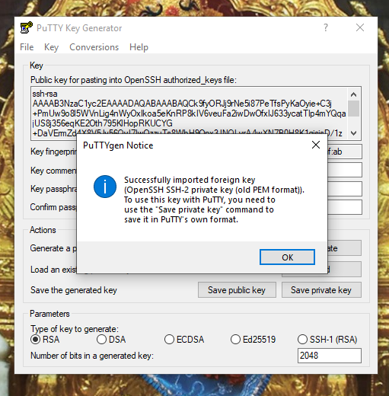

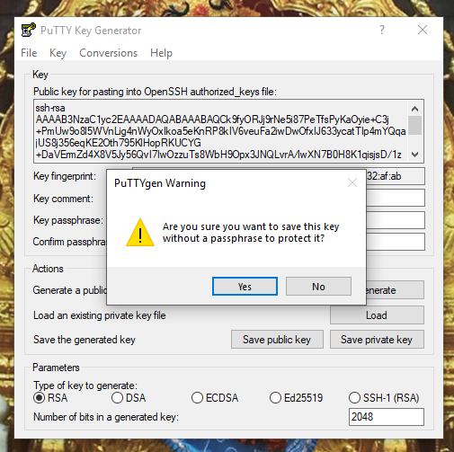

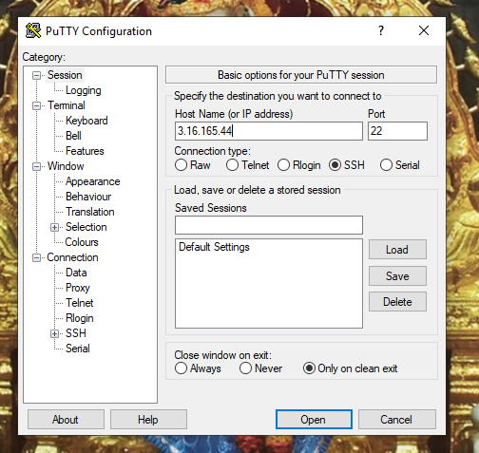

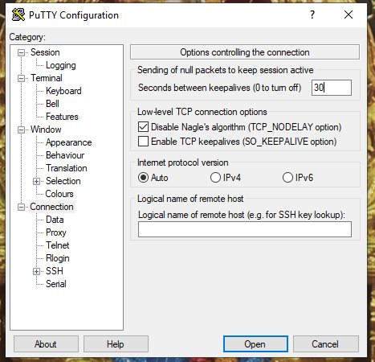

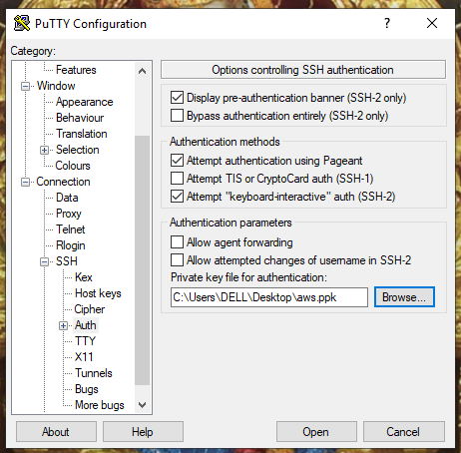

1. **LOGGED IN EC2 BLACK SCREEN:**

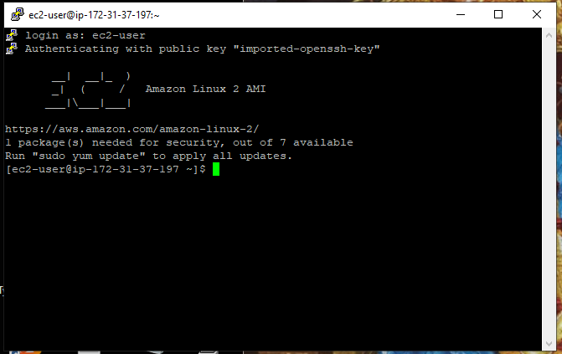

**S3: Simple Storage Service**

1. **CREATING A BUCKET:**

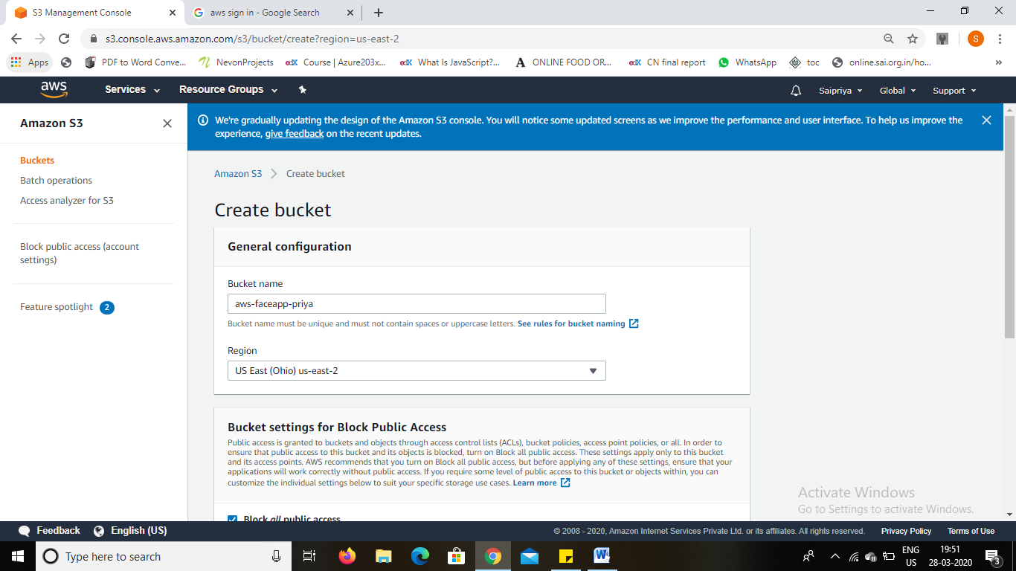

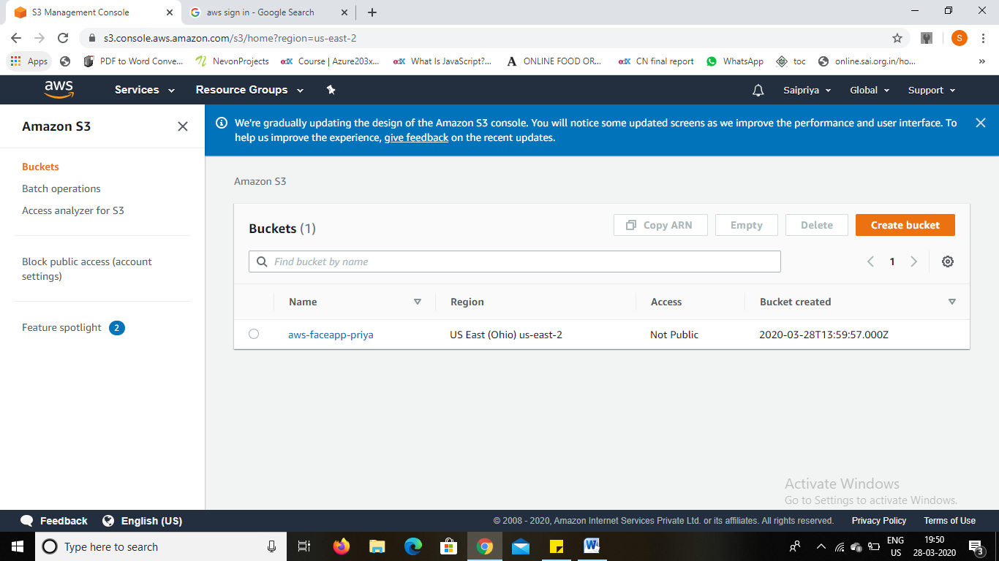

1. **UPLODING OBJECT:**

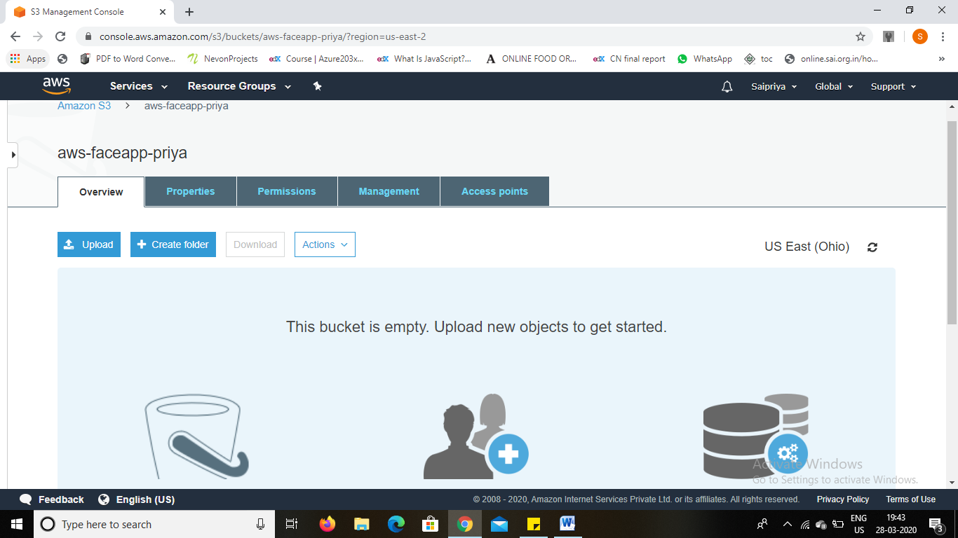

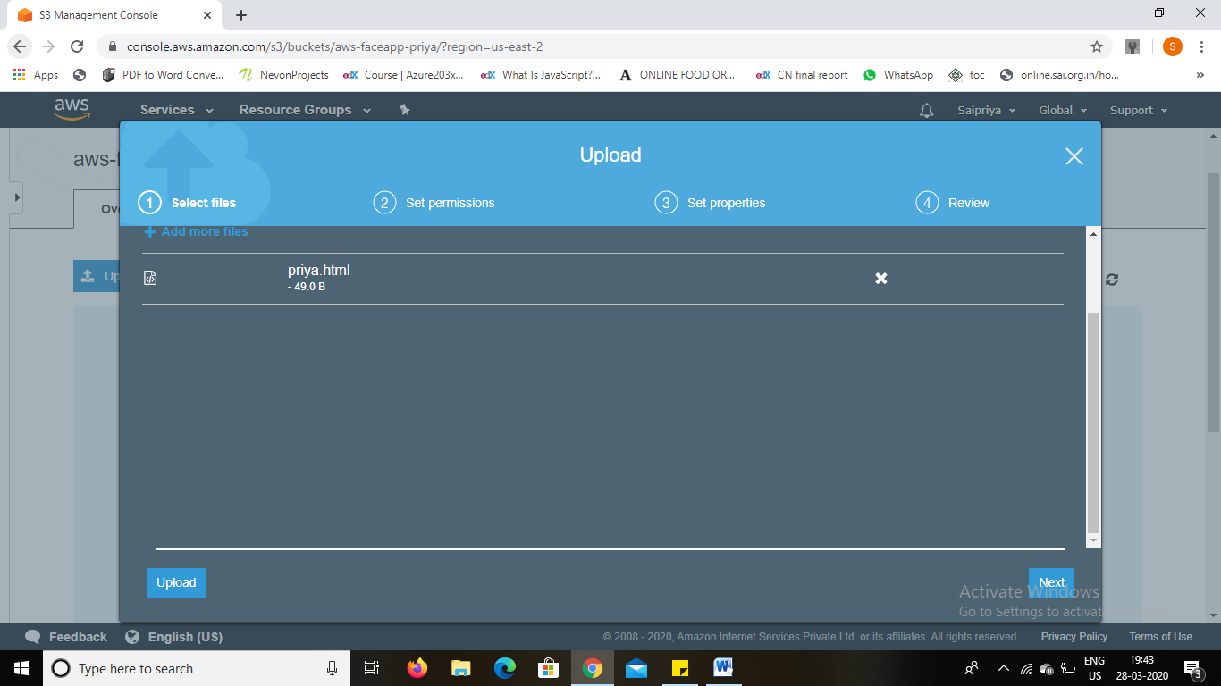

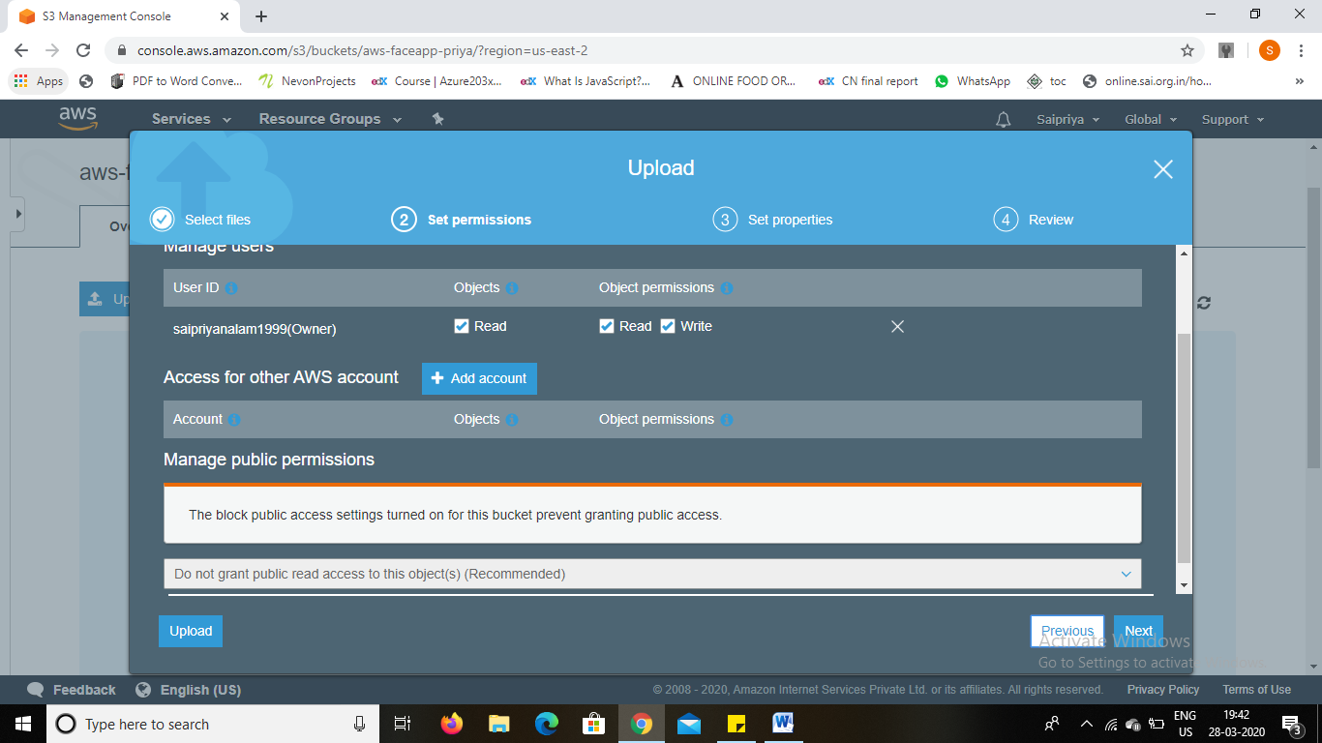

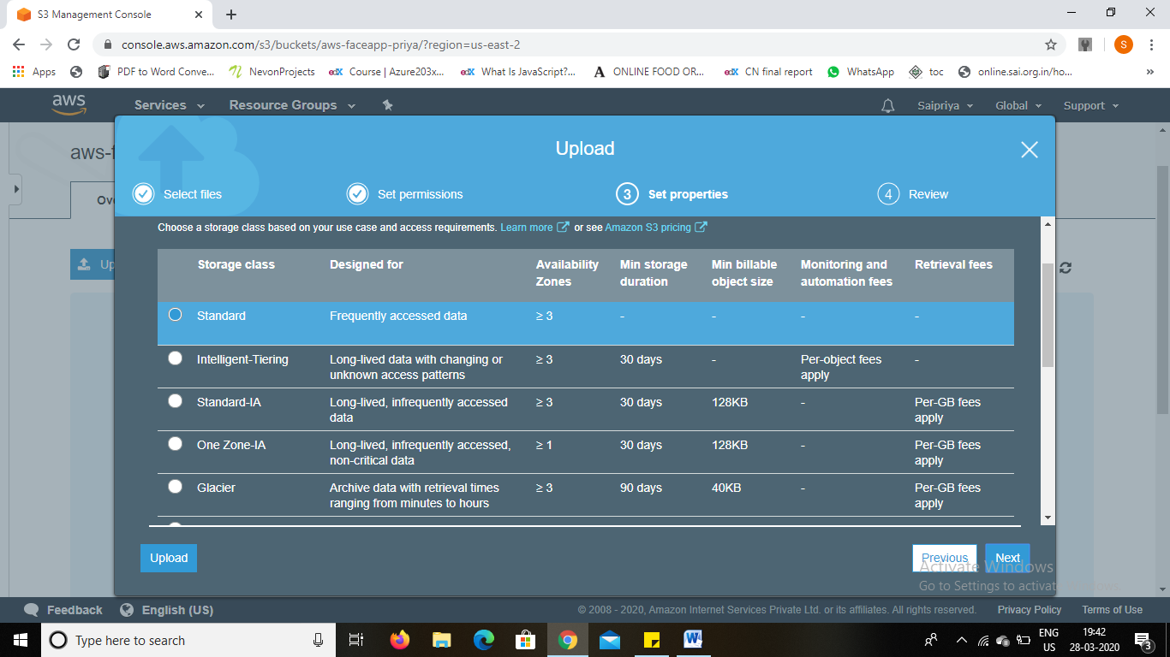

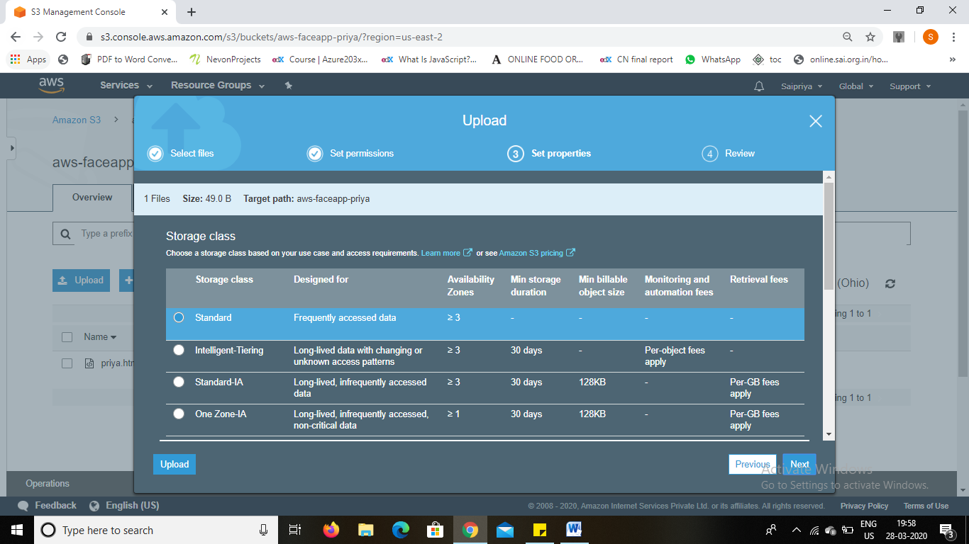

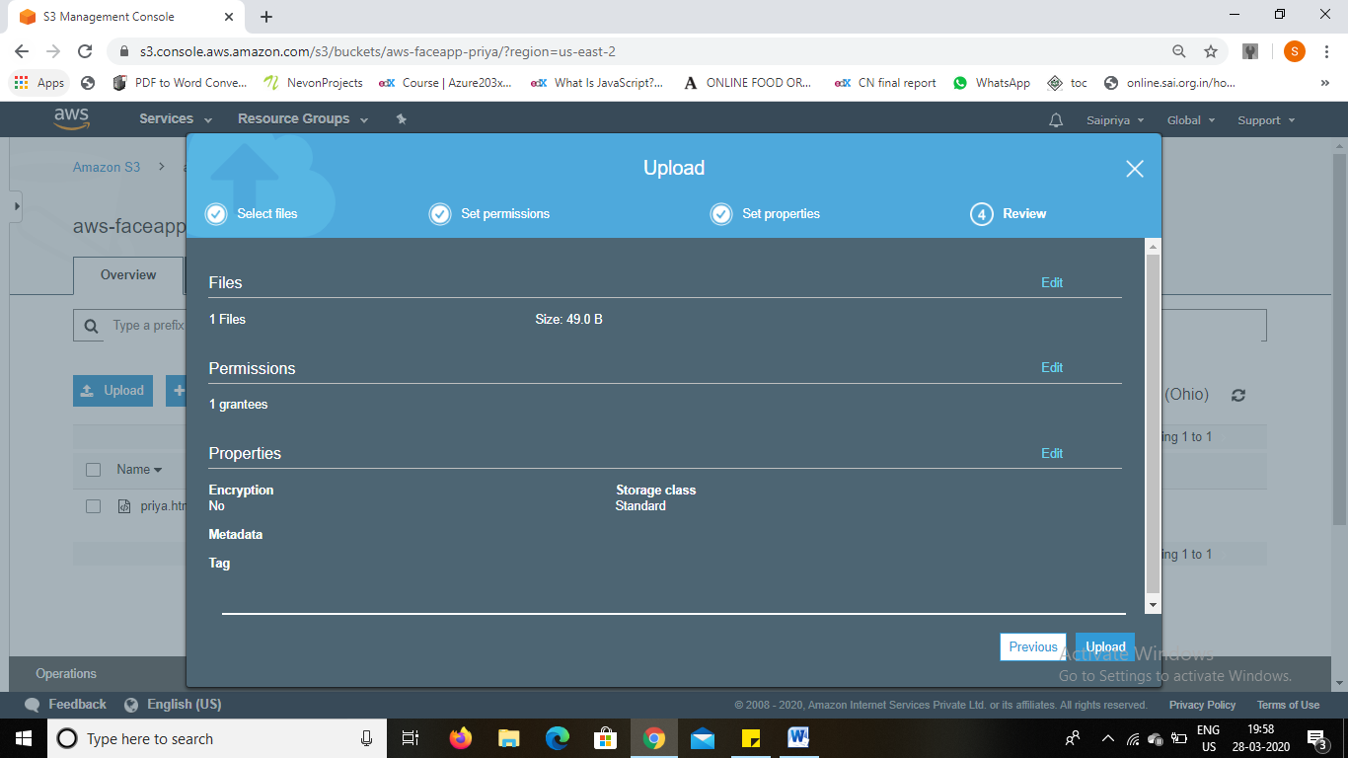

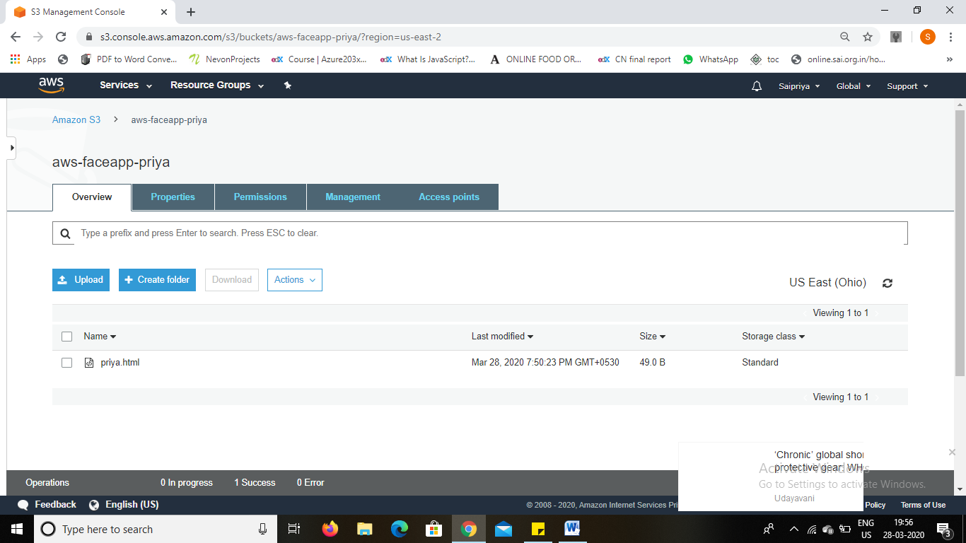

1. **ENABLING STATIC WEBSITE:**

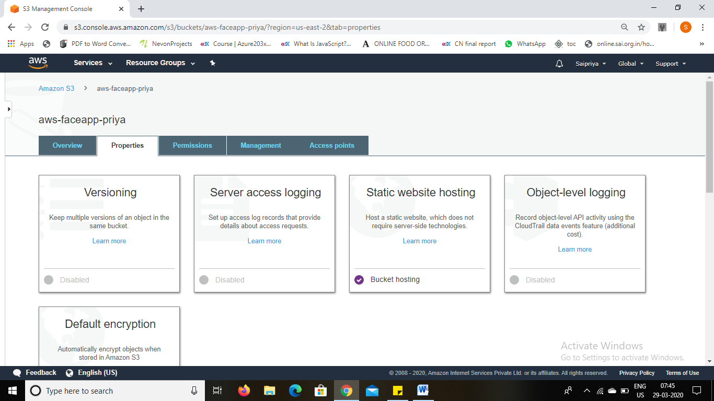

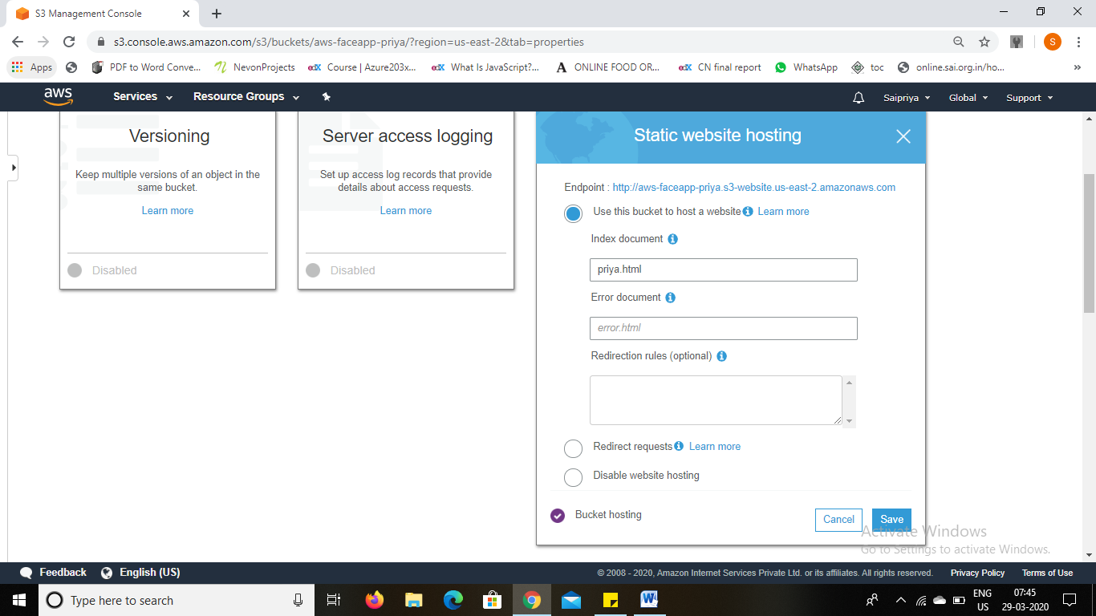

1. **MAKING OBJECT PUBLIC:**

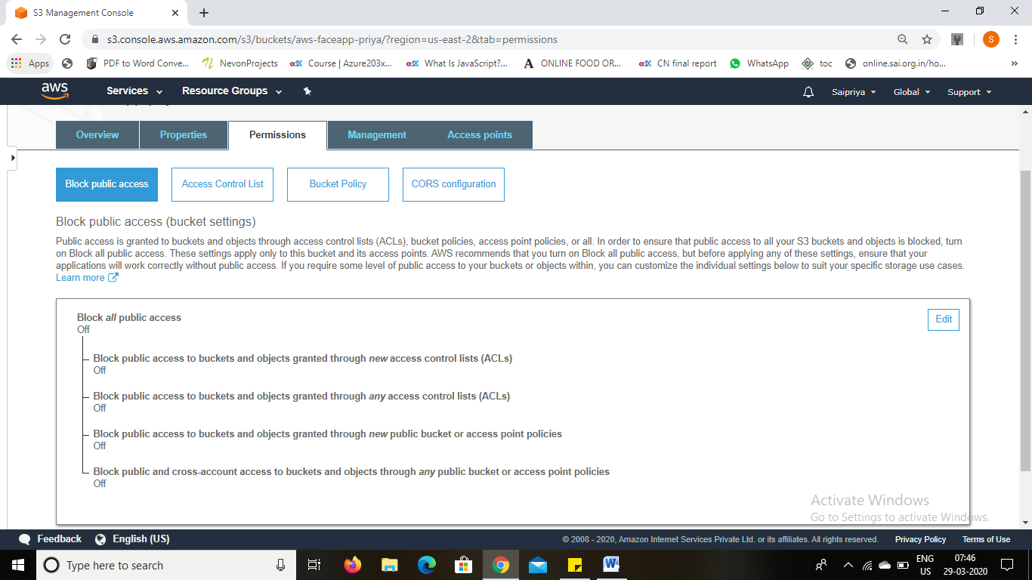

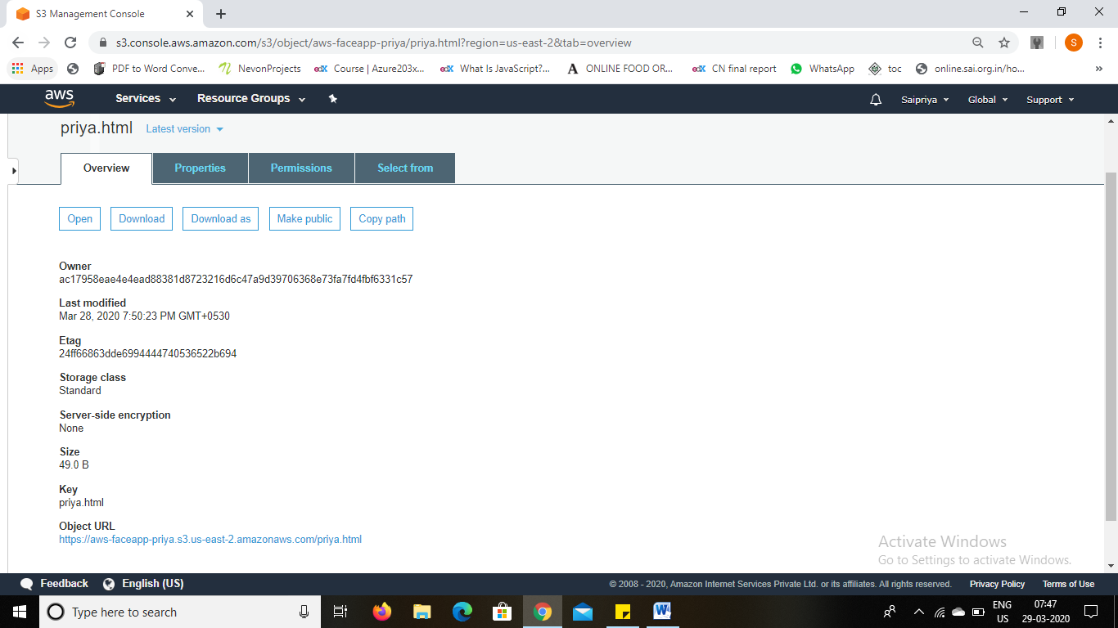

1. **CHECKING S3 LINK ON THE BROWSER:**



**REKOGNITION:**

1. **FACE DETECT:**

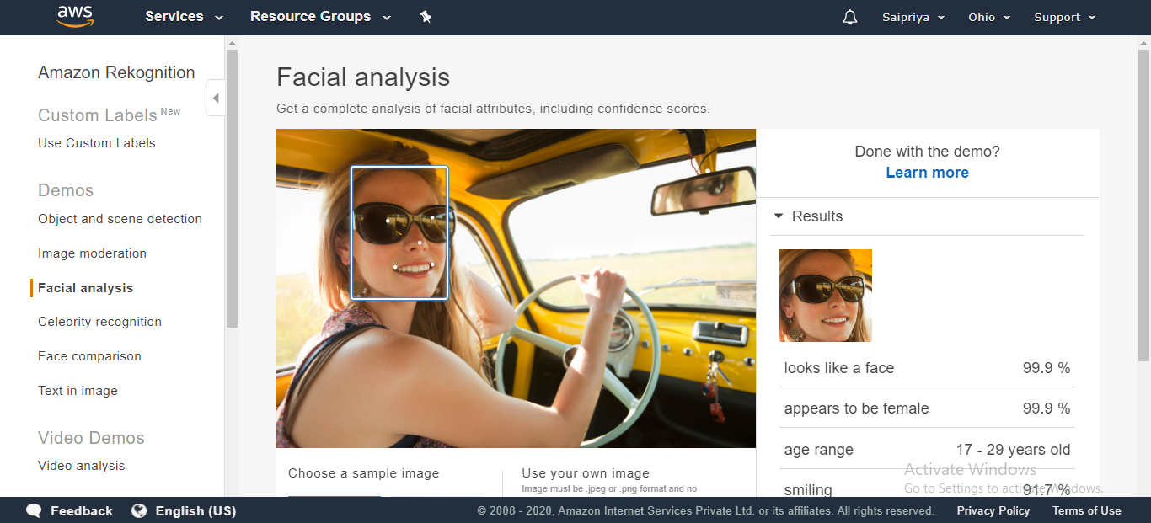

1. **FACE COMPARE:**

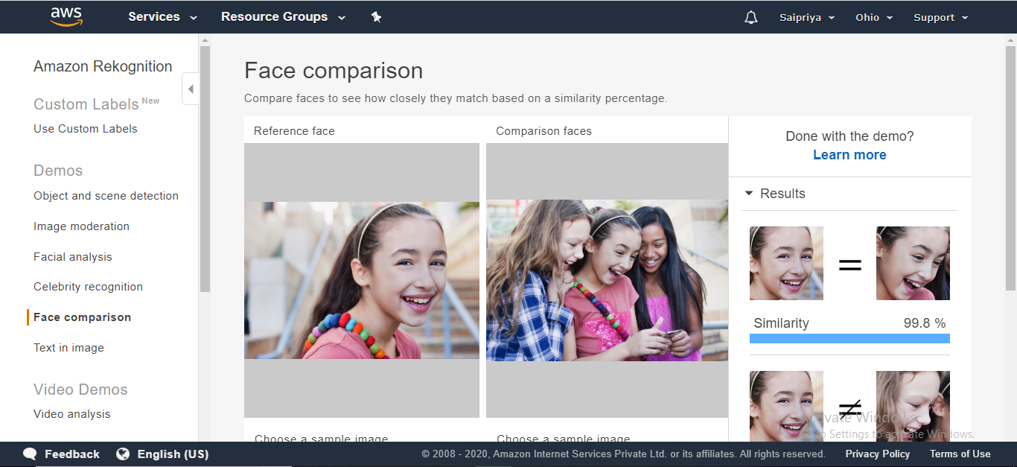

1. **CELEBRITY RECOGNITION:**

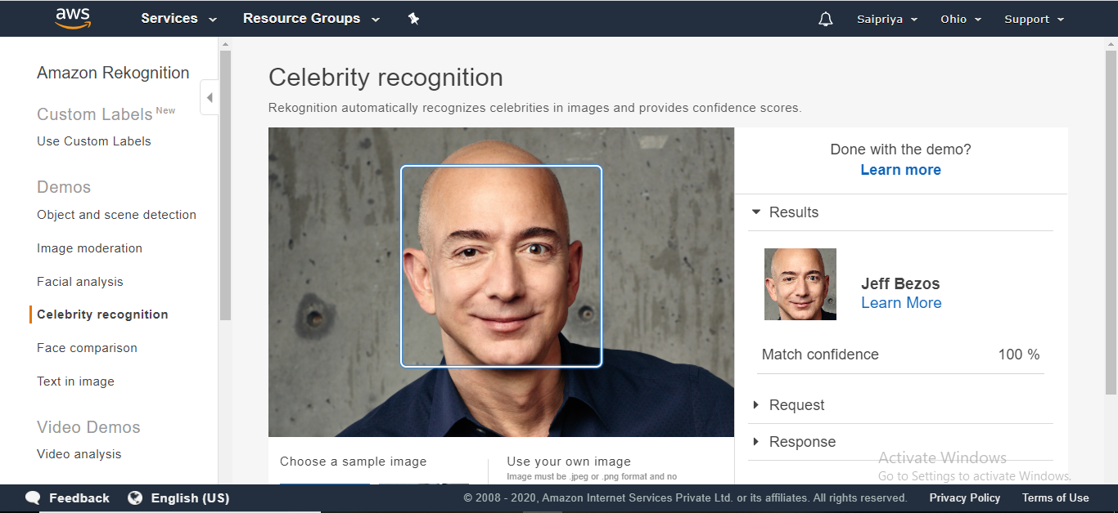

1. **TEXT IN IMAGE:**

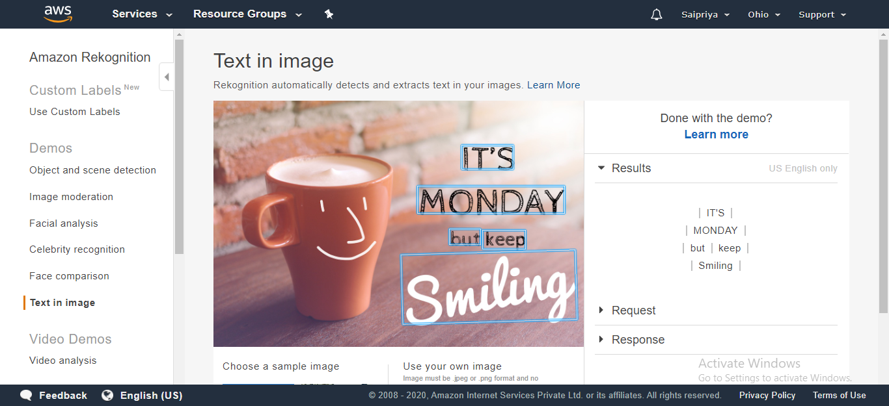

**EC2 & S3:**

1. **INSTALLING AWS SDK:**

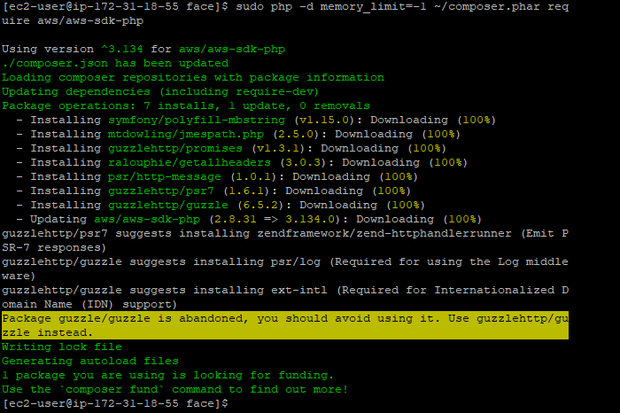

1. **INSTALLING PHP:**

After entering the command- sudo yum install php, you can see the below screen

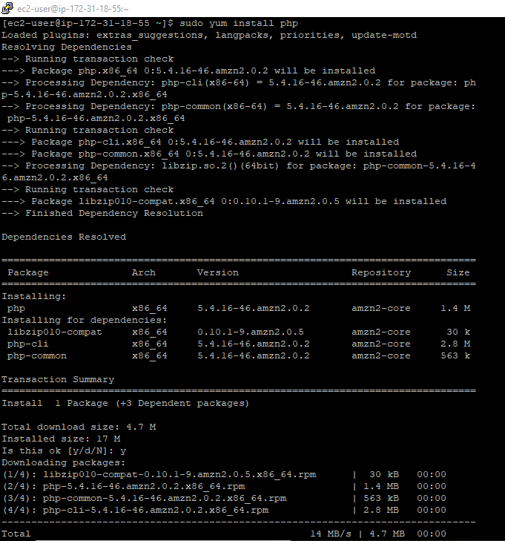

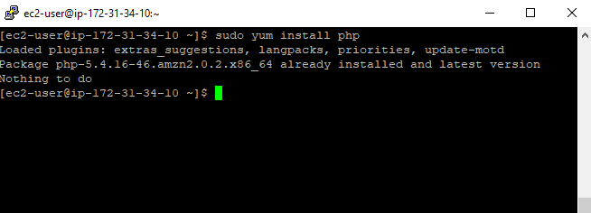

1. **INDEX.PHP FILE CODE:**

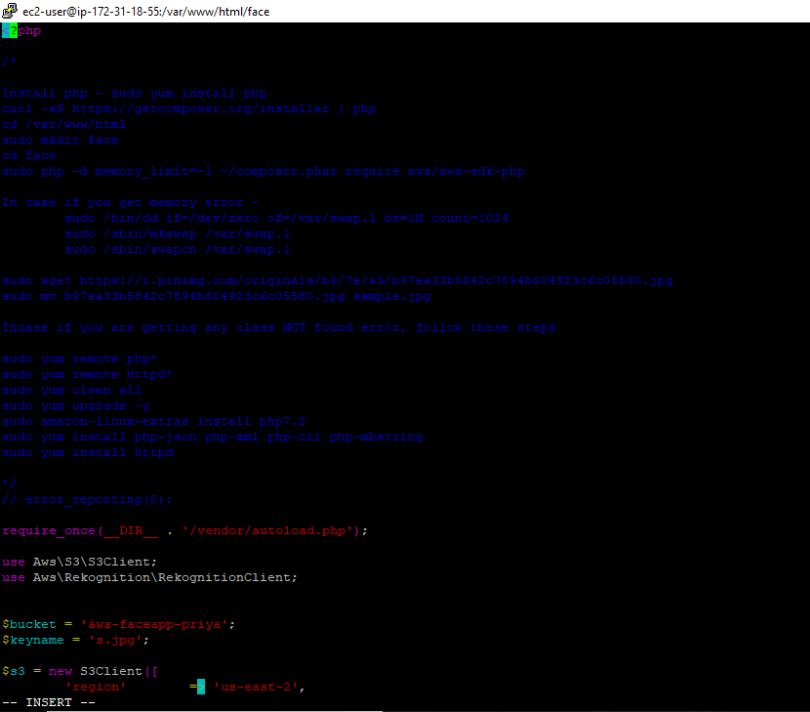

1. **UPLOAD SUCCESS SCREENSHOT:**



**EC2&REKOGNITION:**

1. **FACE DETECT SUCCESS SCREENSHOT:**

